Interview technical documentation
New title suggested by stakeholder: DRP detector
drp stands for Diabetic retinopathy.

There is a combined image for both eyes named “wide field fundus/retina photo” which is taken with a machine available at the stakeholders workplace. Might be worth looking into to see if the application supports it.
Stakeholder thinks he cannot provide said images for testing, but is still interested in the result.
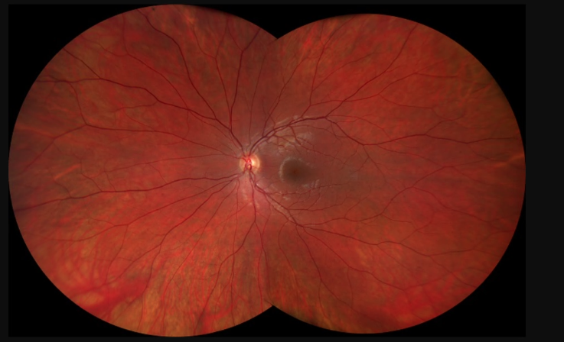

Prototype
Check images button is somewhat pointless since you want to check all images imported in al scenarios.

Explain judgement should be optional because if the application works its not needed for the user. It would be “interesting to look at” but not needed for regular use.
If the program is not accurate enough to be blindly trusted, the explain judgement button would become required for the application to be trusted.

Export function is useful for patient contacting but should be an automated function that send the data on diagnoses to their general practitioner. This might require an API connected to the patients medical information such as insurance and who to contact.

Requirements
ET8 export image should be a want since its not necessary for the project, yet complicated to implement because of the personal data required from the patient. There is already a system in place that is used to direct a patient into the right direction that does not require such a feature.
The other Requirements were approved.

